Chapter 19, Solution 83

To get A and C, we open-circuit the output and let I₁ = 1A. The schematic is shown below. When the circuit is saved and simulated, we obtain V₁ = 11 and V₂ = 34.

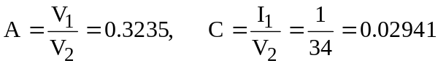

Similarly, to get B and D, we open-circuit the output and let I₁ = 1A. The schematic is shown below. When the circuit is saved and simulated, we obtain V₁ = 2.5 and I₂ = -2.125.

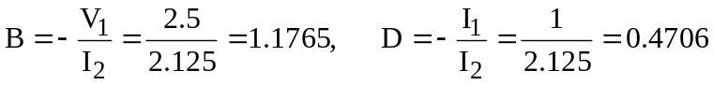

Thus,

